West Virginia Board of Examiners for Speech-Language Pathology and Audiology

November 4, 2025
Time: 5:30 PM Board Meeting
Location: Video Conference Meeting Board Office
99 Edmiston Way – Suite 214
Buckhannon, WV 26201

Present: Board President, Vickie Pullins
Board Secretary, Amber Settles
Board Member, Dr. Michael Squires
Board Member, Heather Waselchalk
Board Member, Amanda Bonner
Board Member, Ruth Rowan

Executive Director, Pamela Coughlin

The November 4, 2025, meeting of the West Virginia Board of Speech-Language Pathology and Audiology was called to order at the Board office at 99 Edmiston Way, Buckhannon, West Virginia, via Zoom at 5:30 PM by Board President Vickie Pullins. Agenda and Zoom invitation were put on the Boards website for the public to attend via telephone.

Amber Settles made a motion to approve the agenda. Dr. Michael Zagarella seconded the motion. Motion carried.

Ruth Rowan made a motion to approve July 8, 2025 minutes. Dr. R. Michael Squires seconded the motion. Motion carried.

Ruth Rowan made a motion to approve PCard for June, July, August, September 2025. Amanda Bonner seconded the motion. Motion carried.

Dr. Squires made a motion to approve financials. Amanda Bonner seconded the motion. Motion carried.

Amber Settles gave an update on the National Council of State Boards of Examiners that was held in Mount Pleasant, South Carolina. Ms. Settles stated there are threats to Boards and Certifications across the country. It was reported that a lobbyist from California went to Utah to help lead the anti-regulation movement. This lobbyist is trying to convince the legislature in Utah that there is nothing that Speech-Language Pathologists or Audiologists do that would harm a consumer. The National Council of State Boards of Examiners and the American Speech-Language-Hearing Association put a testimony together defending the regulation of our professions in Utah.

Ms. Settles reported to the Board the Interstate Compact fees other states are charging. West Virginia being the lowest fee at $25 and Tennessee being the highest fee at $200. Mrs. Pullins noted that our fee is low because we want to invite people to our state because we have a shortage of providers. We want to welcome them to West Virginia to serve our consumers.

Ms. Settles said one of the topics at NCSB was on complaints. The speaker said we need to document the discussion for each complaint and keep it on file along with the outcome of the complaint.

She went on to mention the praxis cheating scandal for Speech-Language Pathology that infiltrated a reddit discussion. They were encouraging people to post questions and options on what they remembered on the praxis exam. There were about 150 people doing this verbatim and 7 people were banned from taking the praxis.

Heather Waselchalk also attended the National Council of State Boards of Examiners. She said she spoke to the ETS presenter for the praxis scandal. She reported that the speaker from
ETS stated that people were hiding behind curtains and under rugs during this scandal.

Ms. Pullins mentioned while at the NCSB Conference they received a jump drive with an instrument to access the effectiveness of our Board. She is going to send it to the Board members and then have a follow up meeting to discuss the perspectives on how effective we are as a Board and what areas we might want to improve.

Ms. Pullins recommended we start putting in our Board minutes all considerations, discussion points and not just what we voted to approve, excluding complaints.

Ms. Pullins stated West Virginia has had a representation at the National Council State Boards since it was formed. Ken Gist from West Virginia University was one of founder’s fathers of the National Council of State Boards. She also mentioned that our Board Secretary, Amber Settles, was elected to the Board of Directors.

Ms. Pullins stated there are 37 states that passed the law for the Interstate Compact but are not taking steps to implement. She went on to mention that she is licensed in Kentucky and was not going to renew her license because she was going to wait until Kentucky went live with Compact. Ms. Pullins was informed by the Kentucky Board that it would be another year before they go live. Dr. Zagarella stated there was a passed the Compact in Legislation and reach out to the Admins for these Boards. They want to find out where they are in the process and they could help them.discussion in the Compact Rule Committee that they may have to give the Compact states a window of time to go live with the Compact or they may have to take it through the Legislative process again.

Ms. Pullins mentioned the glitch we had when we went live with the Compact. The council for the Interstate Compact, Nahale Kalfas,, reached out to Ms. Pullins to report that all the West Virginia licensees that were uploaded to the compactconnect system were showing up eligible for the Compact. Ms. Pullins notified Pam Coughlin about the glitch. Ms. Coughlin and James Doughtry with the Treasure’s office worked out the glitch so that licensees won’t show eligible for Compact until they complete an FBI Criminal Background check.

Our Compact went live October 21, 2025 and Vickie Pullins was the first licensee to purchase a privilege from Louisiana. Kerrilyn Phillips from Louisiana purchased the first privilege from West Virginia.

Vickie Pullins mentioned how proud she is of the Board members and the leadership that Dr. Michael Zagarella has given over the years to the National Council of State Boards. Dr. Zagarella holds an award from the NCSB. Ms. Pullins stated it is the volunteers that make a huge difference even on a national level.

Pam Coughlin informed the Board she transferred $20,588 to general revenue at the end of FY 2025.
Ms. Pullins mentioned looking into lowering our licensing fees since we have such a large amount of surplus funding.

Ms. Pullins recommended we may want to do a rule change in 2026 to lower the license fees and add the compact fee to our rules. Ms. Pullins is going to reach out to Nahale Kalfas (Council for the Compact) to see if it is an issue with not having the compact fee in our Legislative Rules.

Ms. Pullins reached out to the Ohio Board of Speech and Hearing about their Legislative Rules for Hearing Aid Dealer Company license. Their Rule states a person that owns the practice is required to be licensed even if they are an Audiologist. Also, their Rule states "Hearing Aid Dealer company license is for firms, partnerships, corporations that sell prescription hearing aids”. Ms. Pullins asked the Executive Director for the Ohio Board, Greg Thorton, if an Audiologist selling hearing aids needs a Hearing Aid Dealer company license and he said “yes”.

Dr. Michael Squires and Dr. Zagarella stated the WV Code 30 -32-14b states the following:

(b) A person licensed under this article as an audiologist is not required to obtain a license under the provisions of article twenty-six of this chapter.

Dr. Squires updated the Board on the Audiologist that was made to license his company as a Hearing Aid Dealer company as part of a disciplinary action. Ms. Pullins will reach out to the Attorney General office to get clarification on the complaint that was filed against the Audiologist and why he was made to buy a Hearing Aid Dealer company license. Dr. Squires informed the Board that the Audiologist is not going to renew his company license until he gets some clarification.

Ms. Pullins asked the Audiology Board members why Audiologists don't have to pay for a Hearing Aid Dealer license to dispense hearing aids? Dr. Zagarella stated when they did the Law for Audiologists, they put in that Audiologists are excluded from getting a hearing aid dealer license (WV Code 30-32-14b).

Amanda Bonner stated she did not understand why the Audiologists do not need a Hearing Aid Dealer license if they are dispensing hearing aids. Ms. Pullins stated the Audiologists do not have to have a license to dispense hearing aids because when the Rules were promulgated, they made sure the Audiologists with Doctorate degrees did not have to pay for a Hearing Aid Dealer license to dispense hearing aids.

Vickie Pullins asked the Board if they would want to do away with licensing Hearing Aid Dealer companies. Dr. Zagarella and Dr. Squires agreed the Board needs to get away from licensing hearing aid dealer companies to avoid these same situations in the future. Amber Settles, Ruth Rowan, and Heather Waselchalk agreed with the Audiologist.

Ms. Pullins would like to meet again in January 2026 to discuss what everyone found out about the Hearing Aid Dealer company license, elect officers and discuss Pam Coughlin’s salary.

Pam Coughlin informed the Board that the International Hearing Society (HIS) is raising the ILE written exam fee $250 to $260.

Dr. Zagarella made motion to adjourn. Amanda Bonner seconded motion. Motion carried.

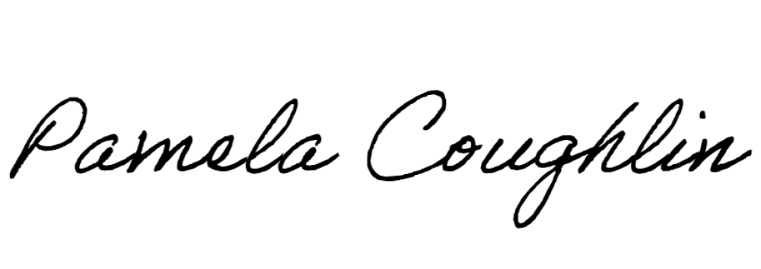
Respectfully submitted,

Pamela Coughlin, Executive Director for
Amber Settles, Board Secretary

