West Virginia Board of Examiners for Speech-Language Pathology and Audiology

December 5, 2025
Time: 5:30 PM Board Meeting
Location: Video Conference Meeting Board Office
99 Edmiston Way – Suite 214
Buckhannon, WV 26201

Present: Board President, Vickie Pullins
Board Secretary, Amber Settles
Board Member, Dr. Michael Squires
Board Member, Heather Waselchalk
Board Member, Amanda Bonner
Board Member, Ruth Rowan
Board Attorney, Joanne Vella

Executive Director, Pamela Coughlin

The December 5, 2025, meeting of the West Virginia Board of Speech-Language Pathology and Audiology was called to order at the Board office at 99 Edmiston Way, Buckhannon, West Virginia, via Zoom at 5:30 PM by Board President Vickie Pullins. Agenda and Zoom invitation were put on the Boards website for the public to attend via telephone.

Vickie Pullins started off the meeting by asking one of the Audiologists to give the Board members a refresher on the Audiologist that was made to pay for a Hearing Aid Dealer company license. Dr. Squires explained to the members that the Audiologist fitted the consumer with a set of hearing aids. The patient was dissatisfied with their hearing aids but did not make it known until months later after the purchase.
Dr. Squires said to his knowledge, the Audiologist was attempting to make it right and work with the patient, but the patient made a complaint to the Attorney General office.

The Attorney General’s office did their investigation and ultimately the resolution was that the Attorney General required the Audiologist to refund money for the hearing aids and penalized him “to the tune of paying for dispensing license for his business”. Dr. Squires stated that the dispensing license for hearing aids are not in our Legislation Rules for Audiologists.

Ms. Pullins added some information about the Audiologist. She spoke with the Attorney General’s office and to the Audiologist. Ms. Pullins was confused why the complaint never came through our Board and why it went through the Hearing Aid Dealers Board. The Audiologist told Ms. Pullins that the complaint did go through our Board. Ms. Pullins reached out to Pam Coughlin to see if there was any information about the complaint in our records. Ms. Coughlin could not find the complaint. All she had was a copy of the letter from the Attorney General that was addressed to the Board of Hearing Aid Dealers. Dr Michael Zagarella, who has been on the Board a long time had no recollection of this complaint against the Audiologist.

Ms. Pullins informed the Board that she found out the Audiologist that is paying the Hearing Aid Dealer company license was on the Board of Hearing Aid Dealers. Ms. Pullins talked with the Attorney from the Attorney General’s office and informed him that the Audiologist did not need a company license for his practice through the Hearing Aid Dealer Board because of WV Code §30-32-14b. Ms. Pullins stated that the Attorney stated that because the Audiologist’s practice was incorporated the company needed to be licensed with the Hearing Aid Dealer Board.

Ms. Pullins also shared that she spoke to the Audiologist against whom the complaint was filed. She did not know what role our Board has to play in this, except that we have collected the company license fee since the Hearing Aid Dealer Board merged with our Board in 2023. Ms. Pullins stated the Audiologist is wanting a refund on his company license fees he paid to the Board. The Board members agreed to refund the fees for the last 2 years and Joanne Vella agreed.

Ms. Pullins reminded the Board the Audiologist did not pay the renewal fee in 2025 because of our Board’s WV Code §30-32-14b. Dr. Squires volunteered to call the Audiologist and let him know what the Board decided. Dr. Michael Squires made a motion to refund $240 to the Audiologist for the renewal fee of his company license for the for 2023 and 2024. Ruth Rowan seconded the motion. Motion carried.

Ms. Pullins opened discussion on Pam Coughlin’s salary. She stated last year Pam Coughlin received the 5% percent raise that our Governor, James Justice, gave to all state employees. Ms. Pullins mentioned the amount of work Ms. Coughlin put into the Interstate Compact to get our state up and running. West Virginia was the first state to get all data entered into the CompactConnect system. She mentioned that Ms. Coughlin administers our board with no part-time assistance which is a big job.

Ms. Pullins suggested a 10% raise for Pam Coughlin but asked the Board members for their input.
Dr. Squires and Ruth Rowan agreed to the 10%. Dr. Squires recommended an even $5000 raise. Amanda Bonner asked who approves the raises for Ms. Coughlin and Ms. Pullins said it was the Board. Dr. Squires made a motion to increase Pam Coughlin’s salary by $5000. Ruth Rowan seconded the motion. Motion carried. Ms. Pullins mentioned how grateful the board is for Pam Coughlin’s hard work.

Ms. Pullins stated the Board will meet again in January to elect officers so she can step aside, and Ms. Coughlin will have our minutes ready to approve.

Dr. Squires made a motion to adjourn. Amber Settles seconded motion. Motion carried.

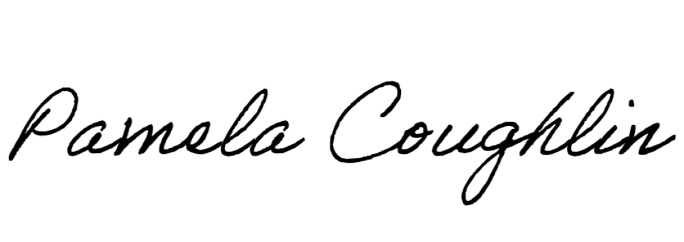
Respectfully submitted,

Pamela Coughlin, Executive Director
for
Amber Settles, Board Secretary

