West Virginia Board of Examiners for
Speech-Language Pathology and Audiology

Board Members
Vickie Pullins, M.A., CCC-SLP, President
Amber Settles, M.Ed. CCC-SLP, Secretary

Dr. Michael J. Zagarella, Au.D., CCC-A

R. Michael Squires, Au.D., F-AAA
Heather Waselchalk, M.S. CCC-SLP
Amanda Bonner, Hearing Aid Specialist
Ruth Rowan, Citizen Member

Pamela Coughlin, Executive Director

January 15, 2026

BOARD MEETING AGENDA
VIA ZOOM CONFERENCE
99 EDIMISTON WAY, SUITE 214
BUCKHANNON, WV 26201

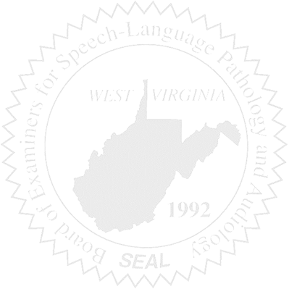
- Call to order
- Approve November 4, 2025 and December 5, 2025 minutes
- Approve PCard for October 2025 and November 2025

Old Business

- Audiologist refunded

New Business

- Vote on new officers
- Sponsor WVSHA Conference
- New E-Travel
- Purchasing Audit 1/7/2025
- Marshall University SLPA Certificate program
- Approve travel for Vickie and Amber to attend NCSB in Colorado

Complaints

- Hearing Aid Dealer Complaint #6

