West Virginia Board of Examiners for
Speech-Language Pathology and Audiology

Board Members
Vickie Pullins, M.A., CCC-SLP, President
Amber Settles, M.Ed. CCC-SLP, Secretary

Dr. Michael J. Zagarella, Au.D., CCC-A

R. Michael Squires, Au.D., F-AAA
Heather Waselchalk, M.S. CCC-SLP
Amanda Bonner, Hearing Aid Specialist
Ruth Rowan, Citizen Member

Pamela Coughlin, Executive Director

BOARD MEETING AGENDA
VIA ZOOM CONFERENCE
99 EDIMISTON WAY, SUITE 214
BUCKHANNON, WV 26201

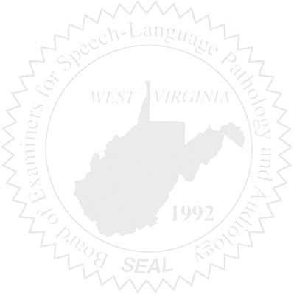
- Call to order
- Approve November 4, 2025 and December 5, 2025 minutes
- Approve PCard for November and December 2025

Old Business

- Audiologist refunded

New Business

- Vote on new officers
- Sponsor WVSHA Conference
- New E-Travel
- Purchasing Audit 1/7/2025
- Marshall University SLPA Certificate program

Complaints

- Hearing Aid Dealer Complaint #6

