West Virginia Board of Examiners for
Speech-Language Pathology and Audiology

Board Members
Erin Leigh-Ann Browning, M.A., CCC-SLP, President
Vickie Pullins, M.A., CCC-SLP, Secretary

Dr. Michael J. Zagarella, Au.D., CCC-A
Dr. Vernon N. Mullins, Au.D, CCC-A
Joe E. Richards, M.A., Citizen Member

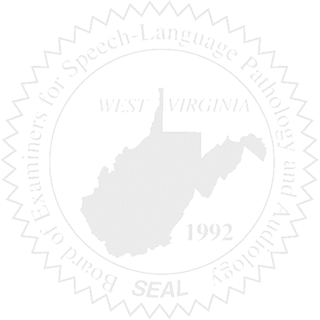
BOARD MEETING
February 22, 2017
Wednesday @ 5:30 PM
Board Office via Video Conference
99 Edmiston Way – Suite 214
Buckhannon, WV 26201

- Call to Order

- Approval of Minutes – January 26, 2017

- PCard Purchasing Report

- Complaints – Greg Foster, Attorney
- Complaint #46 – SLP working outside scope of practice
- Complaint #44 Supervisor of unlicensed Clinical Fellow – Hearing Update
- Elissa Lindsay Appeal Update, if any – Writ of Mandamus

5. Old Business
- Copier Purchase/Leasing Costs
- Computer Purchase (CPU)

6. New Business
- Legislative Rule Update
- WVSHA Vendor Table
- License Renewal Stats – if available

