West Virginia Board of Examiners for
Speech-Language Pathology and Audiology

Board Members
Dr. Vernon N. Mullins, Au.D, CCC-A, President
Vickie Pullins, M.A., CCC-SLP, Secretary

Dr. Michael J. Zagarella, Au.D., CCC-A
Erin Leigh-Ann Browning, M.A., CCC-SLP,
Joe E. Richards, M.A., Citizen Member

BOARD MEETING AGENDA
June 13, 2022 @ 5:00 PM
Board Office via Video Conference
99 Edmiston Way
Suite 214
Buckhannon, WV 26201

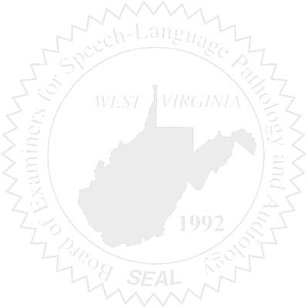
- Call to Order

- Board Meeting Minutes Approval- March 31, 2022 and May 3, 2022

- Financial & PCard Reports – Fiscal Year 2022 Ending 5/31/2022

NEW BUSINESS

- Sponsorship for NCSB

- Laptop Computer

OLD BUSINESS

- Hearing Aid

COMPLAINTS

- #55
- #56 – Review first so Vickie can recuse herself.

