West Virginia Board of Examiners for
Speech-Language Pathology and Audiology

Board Members
Erin Leigh-Ann Browning, M.A., CCC-SLP, President
Vickie Pullins, M.A., CCC-SLP, Secretary

Dr. Michael J. Zagarella, Au.D., CCC-A
Dr. Vernon N. Mullins, Au.D, CCC-A
Joe E. Richards, M.A., Citizen Member

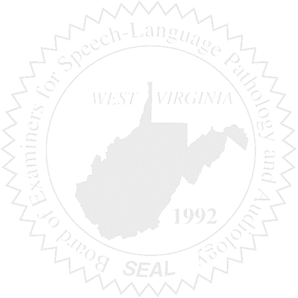
BOARD MEETING
September 6, 2017 @ 5:30 PM
Board Office via Video Conference
99 Edmiston Way
Suite 214
Buckhannon, WV 26201

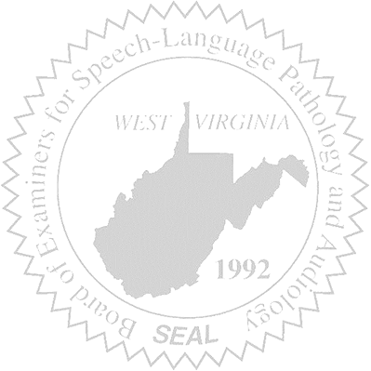
- Call to Order

- Approval of Minutes – July 14, 2017 Meeting

- PCard Financials

- Complaints –
- Elissa Lindsay Supreme Court Appeal Update
- Complaint #44 – Bearden/Timeframe
- Complaint #50 – Aud & Patient Files – Consent Decree Sent – Received by AUD on 08/18/2017
- Complaint #51 – SLP & Alleged Fraud, etc – Info sent

- Old Business
- NCSB
- RN with AUD taxonomy code for NPI number update

- New Business

