West Virginia Board of Examiners for
Speech-Language Pathology and Audiology

Board Members
Erin Leigh-Ann Browning, M.A., CCC-SLP, President
Vickie Pullins, M.A., CCC-SLP, Secretary

Dr. Michael J. Zagarella, Au.D., CCC-A
Dr. Vernon N. Mullins, Au.D, CCC-A
Joe E. Richards, M.A., Citizen Member

BOARD MEETING AGENDA

April 4, 2019 @ 4:00 PM
WVSHA Conference – Bridgeport Conference Center
300 Conference Center Way
Bridgeport, WV 26330

Also available via Zoom Meeting Room #4061741481

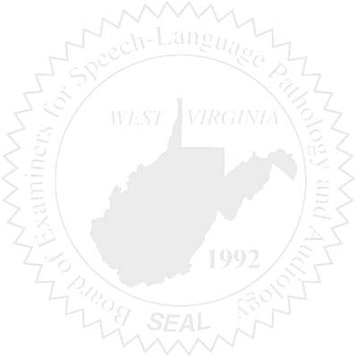
- Call to Order

- Approval of Minutes – February 19, 2019 Meeting

- Financial & PCard Report

OLD BUSINESS

- Legislative Updates
- Legislative Rule 29-01 Modification
- WVU Intern
- Public Outreach

NEW BUSINESS

- Staff Salary – Erin Browning
- License Renewal Report
- Thentia Regulatory Technology – Database
- NCSB Conference Sponsorship

