West Virginia Board of Examiners for
Speech-Language Pathology and Audiology

Board Members
Erin Leigh-Ann Browning, M.A., CCC-SLP, President
Vickie Pullins, M.A., CCC-SLP, Secretary

Dr. Michael J. Zagarella, Au.D., CCC-A
Dr. Vernon N. Mullins, Au.D, CCC-A
Joe E. Richards, M.A., Citizen Member

BOARD MEETING AGENDA

May 23, 2019 @ 5 PM
Board Office via Zoom Video Conference
99 Edmiston Way, Suite 214
Buckhannon, WV 26201

- Call to Order

- WVU Intern Introduction

- Nick Aliberti – Inlumon – Regulatory Software – 15 to 20 min presentation
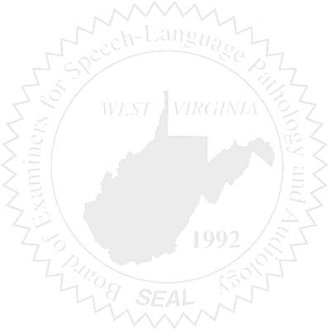
- Approval of Minutes – April 4, 2019 Meeting

- PCard Report

COMPLAINT #52 – Probation Supervision Update
COMPLAINT #54 – New

OLD BUSINESS

- Rule 29-01 Modification Status
- Web Based Database – inLumon

NEW BUSINESS

- SB396 Waiver of fees timeline
- Interstate License Compact - Vickie

