West Virginia Board of Examiners for
Speech-Language Pathology and Audiology

Board Members
Erin Leigh-Ann Browning, M.A., CCC-SLP, President
Vickie Pullins, M.A., CCC-SLP, Secretary

Dr. Michael J. Zagarella, Au.D., CCC-A
Dr. Vernon N. Mullins, Au.D, CCC-A
Joe E. Richards, M.A., Citizen Member

BOARD MEETING AGENDA
March 5, 2018 @ 5:00 PM
Board Office via Video Conference
99 Edmiston Way
Suite 214
Buckhannon, WV 26201

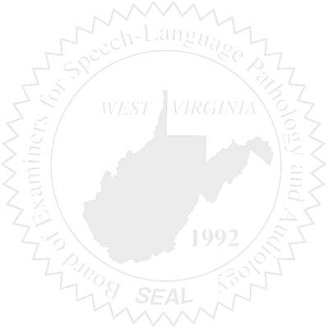
- Call to Order

- Approval of Minutes – December 18, 2017 & January 20, 2018 Meetings

- PCard & Board Financials

- Complaints –
- Complaint #51 – Response to SubPoena for proof of cancelled checks
- Complaint #52 – Update
- Complaint #44 – Bearden Hearing #2

- Old Business
- Online verification - Update
- New Copier update
- WVSHA Vendor Table

- New Business
- Teacher’s Strike & SLPs Questions
- NCSB Planning Session – Vickie Pullins
- FARB Conference Report – Erin Browning

