West Virginia Board of Examiners for
Speech-Language Pathology and Audiology

Board Members

Dr. Michael J. Zagarella, Au.D., CCC-A, President
Vickie Pullins, M.A., CCC-SLP, Secretary
Dr. Vernon N. Mullins, Au.D, CCC-A
Erin Leigh-Ann Browning, M.A., CCC-SLP
Joe E. Richards, M.A., Citizen Member

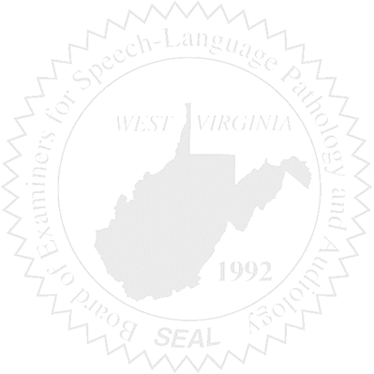
BOARD MEETING
April 15, 2016
6:00 PM
WVSHA Conference – Room to be posted at Conference
Bridgeport Conference Center
300 Conference Center Way
Bridgeport, WV 26330

- Call to Order

- Approval of Minutes – March 23, 2016

- Financial Report including Purchasing Card expenditures, etc.

- Amendment ($10,000) to Budget Ofc. - Patty

- Complaints
- #44 Supervisor of unlicensed CF
- Elissa Lindsay Appeal Update

5. Old Business
- Sanctioning Guidelines
- Position Statement for Website/Supervising PPE/CF
- Jurisprudence Exam – new applicants & Ethics credit?

6. New Business
- Legislative Update
- AUD question re: licensure requirements/consulting/CAOHC trainer
- WVSHA Conference – feedback

