West Virginia Board of Examiners for
Speech-Language Pathology and Audiology

Board Members

Dr. Michael J. Zagarella, Au.D., CCC-A, President
Vickie Pullins, M.A., CCC-SLP, Secretary
Dr. Vernon N. Mullins, Au.D, CCC-A
Erin Leigh-Ann Browning, M.A., CCC-SLP
Joe E. Richards, M.A., Citizen Member

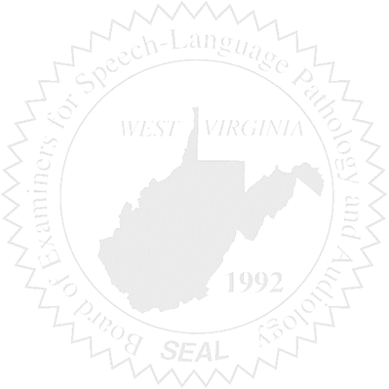
BOARD MEETING
January 6, 2016
5:30 PM
Board Office via Video Conference Call
99 Edmiston Way
Suite 214
Buckhannon, WV 26201

- Call to Order

- Approval of Minutes – November 18, 2015

- Financial Report including Purchasing Card expenditures, etc.

- Complaints
- Ronnie Warrington Legal Issue update
- #43 CF without a license 08/2014 – 07/19/2015
- #44 Supervisor of above CF

5. Old Business
- Elissa Lindsay Appeal Update – Greg Foster, Atty.
- Jurisprudence Exam stats

6. New Business
- Meeting Date for February
- Other New Business

