West Virginia Board of Examiners for
Speech-Language Pathology and Audiology

Board Members

Dr. Michael J. Zagarella, Au.D., CCC-A, President
Vickie Pullins, M.A., CCC-SLP, Secretary
Dr. Vernon N. Mullins, Au.D, CCC-A
Erin Leigh-Ann Browning, M.A., CCC-SLP
Joe E. Richards, M.A., Citizen Member

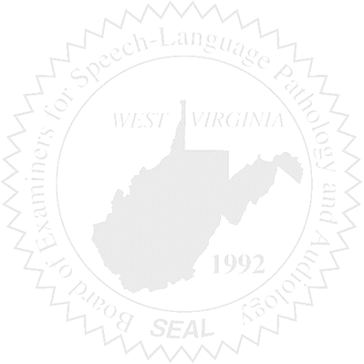
BOARD MEETING
March 23, 2016
5:30 PM
Board Office via Video Conference Call
99 Edmiston Way
Suite 214
Buckhannon, WV 26201

- Call to Order

- Approval of Minutes – February 17, 2016

- Financial Report including Purchasing Card expenditures, etc.

- Complaints
- Ronnie Warrington Legal Issue update
- #44 Supervisor of unlicensed CF
- Elissa Lindsay Appeal Update

5. Old Business
- WVSHA Conference –
  - Co-presenting w/Cheris Frailey-ASHA
  - Brochure & handouts

6. New Business
- Sanctioning Manual - Greg
- April Meeting Date

