West Virginia Board of Examiners for
Speech-Language Pathology and Audiology

Board Members
Erin Leigh-Ann Browning, M.A., CCC-SLP, President
Vickie Pullins, M.A., CCC-SLP, Secretary

Dr. Michael J. Zagarella, Au.D., CCC-A
Dr. Vernon N. Mullins, Au.D, CCC-A
Joe E. Richards, M.A., Citizen Member

BOARD MEETING AGENDA

September 18, 2019 @ 5 PM
Board Office via Zoom Video Conference
99 Edmiston Way, Suite 214
Buckhannon, WV 26201

- Call to Order

- Approval of Minutes – May 23, 2019 Meeting

- PCard & FY Ending 2019 Financial Reports
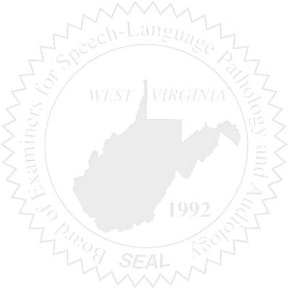
COMPLAINT #52 – Probation Update
COMPLAINT #54 - Falsifying Records

OLD BUSINESS

- Interstate License Compact
- Rule 29-01 & 29-04 Revisions Update
- Web Based Software – inLumon update

NEW BUSINESS

- Provisional Licensees & CE requirement
- Email accounts for Board Business
- Dept. of Ed Revised Medicaid Policies CFYs & SSLPAs
- FARB Forum, January 23-26, 2020 & FARB Regulatory Law Seminar, Oct. 3 – 6, 2019 (Keith)
- WVU Intern – Exit Interview

