West Virginia Board of Examiners for Speech-Language Pathology and Audiology

March 22, 2023 Board Meeting
Time: 5:00 PM
Location: Video Conference Meeting Board Office
99 Edmiston Way – Suite 214
Buckhannon, WV 26201

Present: Board President, Vernon Mullins Board Secretary, Vickie Pullins Board Member, Michael Zagarella Citizen Member, Joe E. Richards Board Member, Heather Waselchalk Board Member, Amber Settles
Executive Director, Pamela Coughlin – Board Office

The meeting was called to order at 5:00 PM by Vernon Mullins, Board President. Introduction of our new board members Heather Wasechalk and Amber Settles.
Vickie Pullins made a motion to approve the minutes for January 11, 2023. Michael Zagarella seconded the motion. Motion carried.

The PCard and Financial Reports were presented. Joe Richards questioned the postage expense. Pam Coughlin explained the postage expense was due to sending the Continuing Education Audit letter by certified mail. Vickie Pullins recommended asking Linda Lyter, the President of WV Association of Licensing Boards if we can change our rule on sending Continuing Education Audit letter by email instead of Certified mail. Joe Richards made a motion to approve all reports as presented. Vernon Mullins seconded the motion. Motion carried.

Old Business

Mission Statement was changed and put on our website.

Vernon Mullins discussed talking to Linda Lyter about Emergency Rules for Hearing Aid Dealers. Pam Coughlin let the board know that she was meeting with Linda Lyter and Kendra Zamora on
March 27, 2023 to discuss Hearing Aid Board.

New Business

Pam Coughlin reviewed the lists of licensees that were short on the continuing education for 2021-2022. If licensees checked the I attest on their renewal application and they are short on their continuing education, Vern Mullins recommended the licensees take one extra hour of Ethics if they are short on their continuing education and to make up the hours, they are short.

Vern Mullins discussed hiring an assistant for Pam Coughlin. Vickie Pullins recommended Pam Coughlin to talk to Linda Lyter about hiring an assistant.

Vernon Mullins let the board members know that the Legislative Audit was canceled and will be rescheduled soon.

Pam Coughlin informed the board that she will set up a table at the WVSHA conference on March 30, 2023 and March 31, 2023. Vickie Pullins discussed the presentation she will do for the graduate students. Vickie Pullins made a motion to approve the $100 fee for the table at WVSHA. Joe Richards seconded the motion. Motion carried.

Vickie Pullins recommended to reach out to Linda Lyter about Per Diem for Board members when traveling.

Vickie Pullins discussed doing a new board member training for the new members with Michael Zagarella late April or May 2023.

Vickie Pullins made a motion to adjourn. Joe Richards seconded the motion. Meeting adjourned at 6:01PM.

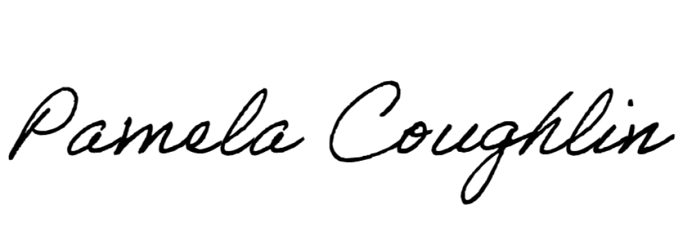
Respectfully submitted,

Pamela Coughlin, Executive Director for
Vickie Pullins, Board Secretary

