West Virginia Board of Examiners for
Speech-Language Pathology and Audiology

Board Members
Erin Leigh-Ann Browning, M.A., CCC-SLP, President
Vickie Pullins, M.A., CCC-SLP, Secretary

Dr. Michael J. Zagarella, Au.D., CCC-A
Dr. Vernon N. Mullins, Au.D, CCC-A
Joe E. Richards, M.A., Citizen Member

BOARD MEETING
October 18, 2017 @ 5:30 PM
Board Office via Video Conference
99 Edmiston Way
Suite 214
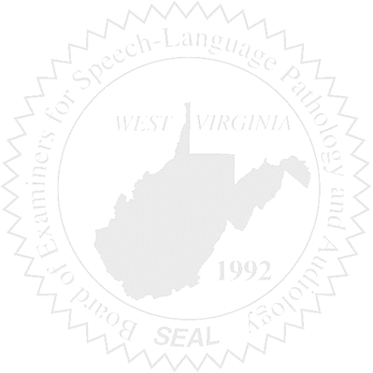
Buckhannon, WV 26201

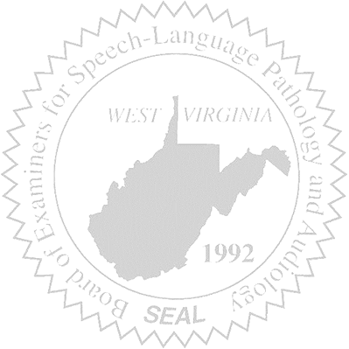
- Call to Order

- CE Broker Demo
- Approval of Minutes – September 6, 2017 Meeting

- PCard & Financials

- Complaint Updates

- Old Business
- CE Broker
- Lease of Copier
- Update of RN/HIS with Audiology Taxonomy Code
- Bosley Provisional License Update

- New Business
- Annual Report
- New Attorney
- FARB
- Online License Verification
- Auditor’s Board Training

