West Virginia Board of Examiners for
Speech-Language Pathology and Audiology

Board Members
Dr. Vernon N. Mullins, Au.D, CCC-A, President
Vickie Pullins, M.A., CCC-SLP, Secretary

Dr. Michael J. Zagarella, Au.D., CCC-A
Joe E. Richards, M.A., Citizen Member

BOARD MEETING AGENDA
March 22, 2023 @ 5:00 PM
Board Office via Video Conference
99 Edmiston Way
Suite 214
Buckhannon, WV 26201

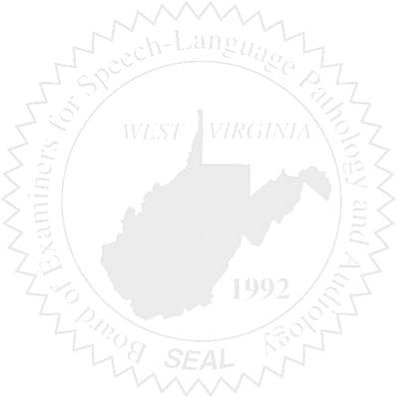
- Call to Order

- Board Meeting Minutes Approval- January 11, 2023

- Financials for January and February 2023 & PCard Report

NEW BUSINESS

- New Board Members and Board Training
- CE Audit
- Hiring Assistant
- Legislative Audit (Auditor canceled for 3/24/2023)
- WVSHA Conference March 30-31, 2023 at Stonewall Resort
- Travel Reimbursement
- WV Code 30-32-5

OLD BUSINESS

- Mission Statement was changed on the Website.
- Hearing Aid Dealers- Emergency Rule Forms, Training, Etc.
- Consider authorizing Executive Director or President to sign documents for Hearing Aid Dealers.

