West Virginia Board of Examiners for Speech-Language Pathology and Audiology

January 11, 2024 Board Meeting
Time: 5:00 PM
Location: Video Conference Meeting Board Office
99 Edmiston Way – Suite 214
Buckhannon, WV 26201

Present: Board Secretary, Vickie Pullins Board Member, Michael Zagarella Board Member, Heather Waselchalk Board Member, Amber Settles
Board Member, R. Michael Squires
Board Member, Amanda Bonner
Executive Director, Pamela Coughlin

The January 11, 2024, meeting of the West Virginia Board of Speech-Language Pathology and Audiology was called to order in the Board office at 99 Edmiston Way, Buckhannon, West Virginia, via Zoom at 5:02 PM by Board Secretary Vickie Pullins. Agenda and Zoom invitation were put on the Boards website for the public to attend via telephone.

Introductions

Vickie Pullins introduced and welcomed our new Audiology Board member, Dr. R. Michael Squires.

Approve Minutes

Michael Zagarella motioned to approve the minutes for October 11, 2023. Amber Settles seconded the motion. Motion carried.

PCard Approval

Michael Zagarella motioned to approve PCard for September, October, and November 2023. Amanda Bonner seconded the motion. Motion carried.

Approve Financials

Michael Zagarella motioned to approve Financials for 2023-year end. . Amanda Bonner seconded the motion. Motion carried.

Review Complaints

A motion was made by R. Michael Squires to go into executive session to discuss 2 complaints, Amanda Bonner seconded the motion. Motion carried.

R. Michael Squires motioned to come out of Executive Session. Heather Waselchalk seconded the motion. Motion carried.

The Board returned to public session. Vickie Pullins moved that; Complaint #55 signed the consent agreement on October 23, 2023 and is in effect. Ms. Pullins also moved that the Board seek more information on Complaint #1 for Hearing Aid Dealer.

NCSB Conference Financials

Vickie Pullins reviewed the Financials for the National Council of State Boards. Ms. Pullins recommended the new Board members to attend the conference in 2024. Amber Settles shared her experience with the NCSB Conference.

Vickie Pullins and Michael Zagarella will set up Board training for R. Michael Squires and Amanda Bonner.

Vickie Pullins recommended Michael Zagarella, Amanda Bonner, and R. Michael Squires review the Practical Exam that is in place now. Amanda Bonner will reach out to the Hearing Aid Dealer Trainees to set up a date for the Practical.

Election of Officers

Michael Zagarella nominated Vickie Pullins for President of the Board. Amanda Bonner seconded the motion. Motion carried.

Vickie Pullins nominated Amber Settles for Secretary of the Board. Amanda Bonner seconded the motion. Motion carried.

Hearing Aid Dealer Application

Pam Coughlin reviewed a Hearing Aid Dealer application received at the Board office. The application stated that the individual was an Audiology Assistant and had a High School Diploma. Ms. Coughlin contacted the Trainee and explained to her an Audiology Assistant, you must have an associate degree from an institution or technical training program to prepare the individual for the Audiology Assistant.

Board Review

Vickie Pullins addressed the issues that were listed on our Board review. Ms. Pullins reviewed the following issues:

- Board meeting agenda and zoom invitation to be posted on website so public members can attend the Board meetings.
- Auditor recommended the Board get a lockbox for the checks we receive at the Board office.
- Board Members attending Auditor training.
- Communicate with the Governor’s office on board members terms.
- Posting a register on our website.
- Website needs updates with more user friendly navigation
- Board office building needs to provide Handicap Accessablity and service under the ADA requirements.
- Board Fees are not excessive.

Website

Pam Coughlin asked the board members to provide a biography and a picture to post on the Board’s website. Members agreed to have them to Ms. Coughlin by February 14, 2024.

Vickie Pullins state she will look at other states and see what type of questions they have posted on their website for FAQ questions.

Vickie Pullins asked Michael Zagarella to write up something on our Agency history so it can be posted on the Boards website.

National Council of State Boards (NCSB)

Vickie Pullins asked the Board to cover her expenses for the National Council State Boards meeting in San Antonio, Texas on February 15th through 18th of 2024. Ms. Pullins is President-Elect and in charge of the conference for 2024. Michael Zagarella made a motion to cover Vickie Pullin’s expenses for NCSB meeting. Heather Waselchalk seconded the motion. Motion carried.

West Virginia Speech-Language and Hearing Association

Pam Coughlin asked the Board to sponsor a table at the WVSHA Conference (WV Speech-Language and Hearing Association). Michael Zagarella explained to the new Board members that we set up a table to get the word out on how licensure works and how we protect the consumers across the state. R. Michael Squires stated he is speaking at the WVSHA conference and he wanted to know if it was a conflict of interest. Vickie Pullins said she did not think so as long as he disclosed that he is a member of the WV Board of Speech-Language Pathology and Audiology. Ms. Pullins explained board members cannot serve on a Professional Organization per the WV state code for chapter 30 boards. Michael Zagarella recommended R. Michael Squires reach out to the Ethics Commission about serving on a Cooperative Board (Cooperative of Audiologists). Amanda Bonner will also reach out to the Ethics Commission pertaining to her being on the West Virginia Hearing Society as the Secretary.

Amanda made a motion to sponsor a table at WVSHA. R. Michael Squires seconded the motion. Motion carried.

Vickie Pullins recommended we have 2 to 3 Board meetings in person at the Board office in Buckhannon each year if possible. Ms. Pullins will be sending out a survey on in person Board meetings.

Amanda Bonner made a motion to adjourn. R. Michael Squires seconded the motion. Motion carried. Meeting adjourned at 6:33 PM.

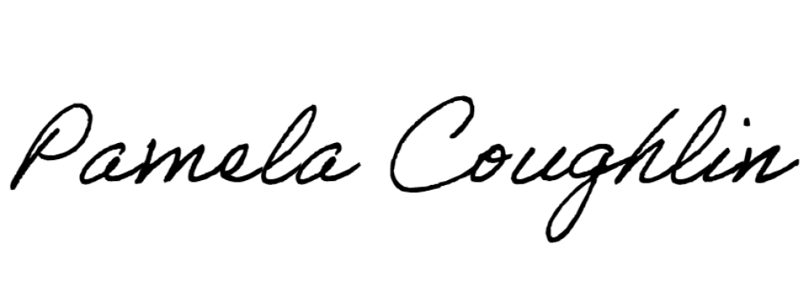
Respectfully submitted,

Pamela Coughlin, Executive Director for
Amber Settles, Board Secretary

