West Virginia Board of Examiners for
Speech-Language Pathology and Audiology

Board Members
Erin Leigh-Ann Browning, M.A., CCC-SLP, President
Vickie Pullins, M.A., CCC-SLP, Secretary

Dr. Michael J. Zagarella, Au.D., CCC-A
Dr. Vernon N. Mullins, Au.D, CCC-A
Joe E. Richards, M.A., Citizen Member

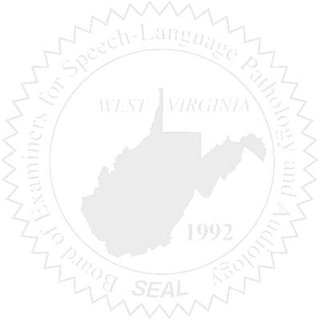
BOARD MEETING
December 13, 2017 @ 5:00 PM
Board Office via Video Conference
99 Edmiston Way
Suite 214
Buckhannon, WV 26201

- Call to Order

- Approval of Minutes – October 18, 2017 Meeting

- PCard & Board Financials

- Complaints –
- Complaint #44 – Bearden/Timeframe, Celeste Barber
- Complaint #51 – SLP & Alleged Fraud, etc – Investigation Findings

- Old Business
- Online verification
- RN with AUD taxonomy code for NPI number update
- Reporting Board Dismissed Complaints to ASHA Ethics - Follow-up from Vickie re: May 3, 2017 Meeting
- Copier Donation
- Update on confirmation of Bosley restitution payments
- Legal Counsel

- New Business
- Office Personnel Job Title – Joe Richards
- SLP Application

