West Virginia Board of Examiners for
Speech-Language Pathology and Audiology

Board Members
Erin Leigh-Ann Browning, M.A., CCC-SLP, President
Vickie Pullins, M.A., CCC-SLP, Secretary

Dr. Michael J. Zagarella, Au.D., CCC-A
Dr. Vernon N. Mullins, Au.D, CCC-A
Joe E. Richards, M.A., Citizen Member

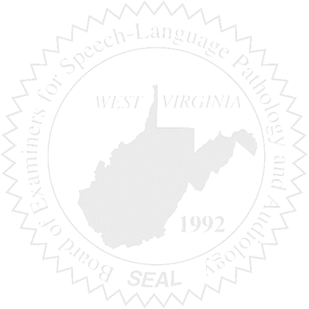
BOARD MEETING
May 3, 2017 @ 5:30 PM
Board Office via Video Conference
99 Edmiston Way
Suite 214
Buckhannon, WV 26201

- Call to Order

- Approval of Minutes – March 31, 2017

- Financial & PCard Purchasing Report

- Complaints – Updates
- Complaint #44 Supervisor of unlicensed Clinical Fellow – Hearing Update
- Elissa Lindsay Appeal Update, if any – Writ of Mandamus
- #48
- #49

5. Old Business
- Legislative Updates

- New Business
- Ethics Investigator – Vern
- Investigator- Greg
- NCSB

