West Virginia Board of Examiners for
Speech-Language Pathology and Audiology

Board Members
Dr. Vernon N. Mullins, Au.D, CCC-A, President
Vickie Pullins, M.A., CCC-SLP, Secretary

Dr. Michael J. Zagarella, Au.D., CCC-A
Erin Leigh-Ann Browning, M.A., CCC-SLP,
Joe E. Richards, M.A., Citizen Member

EMERGENCY BOARD MEETING AGENDA
August 18, 2022 @ 5:00 PM
Board Office via Video Conference
99 Edmiston Way
Suite 214
Buckhannon, WV 26201

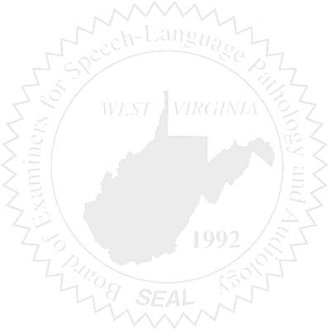
- Call to Order
- Approval minutes for June 13, 2022

Old Business

- NCSB
- Office Computer

Complaints

- Complaint #55

