West Virginia Board of Examiners for

Speech-Language Pathology and Audiology

Board Members

Vickie Pullins, M.A., CCC-SLP, President

Amber Settles, M.Ed. CCC-SLP, Secretary

Dr. Michael J. Zagarella, Au.D., CCC-A

R. Michael Squires, Au.D., F-AAA

Heather Waselchalk, M.S. CCC-SLP

Amanda Bonner, Hearing Aid Specialist

Ruth Rowan, Citizen Member

October 1, 2024 at 5:30PM

BOARD MEETING AGENDA

Board Office via Video Conference

99 Edmiston Way

Suite 214

Buckhannon, WV 26201

1. 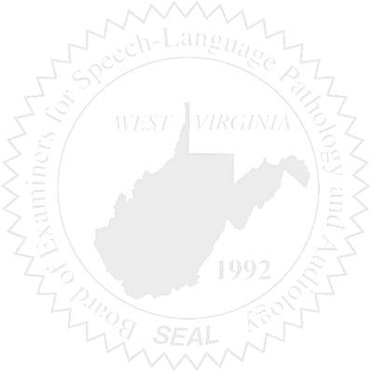Call to order
2. Approve minutes for July 10, 2024 and August 6, 2024
3. Approve Pcard for May, June, July and August 2024

New Business

1. Hearing Aid Dealer Company License ( Renewal)

Old Business

1. Proposed Rules

Complaints

1. #58- Review
2. #59- Review
3. #61 - Review