West Virginia Board of Examiners for

Speech-Language Pathology and Audiology

Board Members

Vickie Pullins, M.A., CCC-SLP, President

Amber Settles, M.Ed. CCC-SLP, Secretary

Dr. Michael J. Zagarella, Au.D., CCC-A

R. Michael Squires, Au.D., F-AAA

Heather Waselchalk, M.S. CCC-SLP

Amanda Bonner, Hearing Aid Specialist

Ruth Rowan, Citizen Member

Pamela Coughlin, Executive Director

January 21, 2025 at 5:30 PM

BOARD MEETING AGENDA

VIA ZOOM CONFERENCE

99 EDIMISTON WAY, SUITE 214

BUCKHANNON, WV 26201

1. 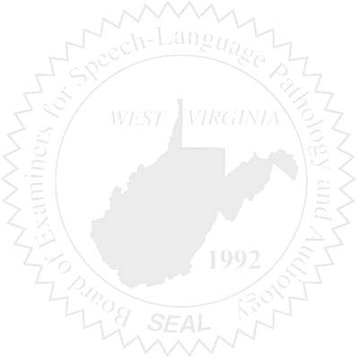Call to order
2. Approve minutes for October 23, 2024
3. Approve Pcard for September, October November 2024
4. Financials

New Business

1. Bill for Background checks
2. NCSB Board meeting for Directors in SC (Approve mileage and lodging)

Complaints

1. Review Consent Agreement for Complaint #59 & 61
2. Review #58