West Virginia Board of Examiners for

Speech-Language Pathology and Audiology

Board Members

Vickie Pullins, M.A., CCC-SLP, President

Amber Settles, M.Ed. CCC-SLP, Secretary

Dr. Michael J. Zagarella, Au.D., CCC-A

R. Michael Squires, Au.D., F-AAA

Heather Waselchalk, M.S. CCC-SLP

Amanda Bonner, Hearing Aid Specialist

Ruth Rowan, Citizen Member

August 6, 2024 at 5:30PM

BOARD MEETING AGENDA

Board Office via Video Conference

99 Edmiston Way

Suite 214

Buckhannon, WV 26201

1. 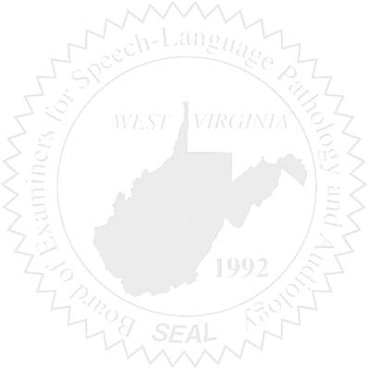Call to order

New Business

1. Open Discussion on Practical Exam

Complaints

1. #59- Review
2. #61 - Review Response from Attorney