West Virginia Board of Examiners for

Speech-Language Pathology and Audiology

Board Members

Vickie Pullins, M.A., CCC-SLP, President

Amber Settles, M.Ed. CCC-SLP, Secretary

Dr. Michael J. Zagarella, Au.D., CCC-A

R. Michael Squires, Au.D., F-AAA

Heather Waselchalk, M.S. CCC-SLP

Amanda Bonner, Hearing Aid Specialist

Ruth Rowan, Citizen Member

July 10, 2024 @ 5:30PM

BOARD MEETING AGENDA

Board Office via Video Conference

99 Edmiston Way

Suite 214

Buckhannon, WV 26201

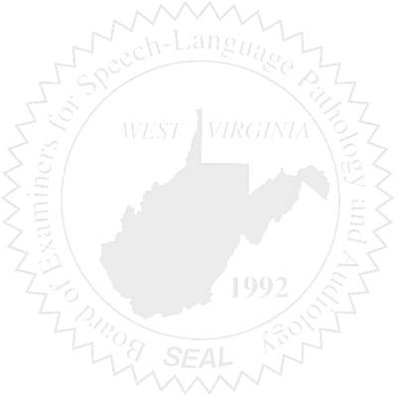

1. Call to Order
2. Approval of May 16 22, 2024 and May 30, 2024 minutes
3. Pcard Approval for April 2024

New Business

1. Open Discussion on Provisional License
2. Part-time help for Pam
3. NCSB Sponsorship
4. Review transcripts for a SLPA.

Old Business

1. Proposed Rules-review public comments

Complaints

1. #58- Review supportive documents
2. #59- Review response(if received) -Dr.. Squires will be recused
3. #3- Review response from Supervisor- Amanda Bonner will be recused
4. #61- Review Complaint