West Virginia Board of Examiners for

Speech-Language Pathology and Audiology

Board Members

Dr. Vernon N. Mullins, Au.D, CCC-A, President

Vickie Pullins, M.A., CCC-SLP, Secretary

Dr. Michael J. Zagarella, Au.D., CCC-A

Amber Settles, M.Ed. CCC-SLP

Heather Waselchalk, M.A. CCC-SLP

Amanda Bonner, Hearing Aid Specialist

Joe E. Richards, M.A., Citizen Member

January 11, 2024

At 5:00PM

BOARD MEETING AGENDA

Board Office via Video Conference

99 Edmiston Way

Suite 214

Buckhannon, WV 26201

1. 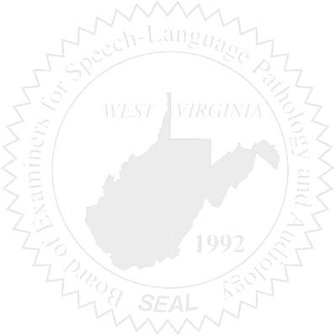Call to Order
2. Approve October 11, 2023 minutes
3. Approve PCard for September, October, and November 2023
4. Financials for the end of 2023 (Calendar Year)

Complaints

1. #55- Consent Agreement signed 10/23/2023
2. #1 Hearing Aid Dealer Consumer Complaint received 12/26/2023

Old Business

1. NCSB Conference Financials for Vickie Pullins and Amber Settles.
2. HAD Practical- Amanada has volunteered to administer the Practical. 2 Individual are ready to take the Practical.

New Business

1. WVSHA 3/14/2024 and 3/15/2023 at Bridgeport Convention Center.

* Last year we did the Silver Package for $100 that allowed us to set up a table.

1. Hearing Aid Dealer Application received 10/18/23. Position listed was an Audiology Assistant.
2. Board Review response submitted 12/22/2023. Interim Meeting of Joint Committee on Government Organization scheduled January 7-9, 2023.
3. Website-
   1. Biography and picture of each member
   2. Will need questions for the FAQ section
   3. Agency History
4. Election of Officers
5. NCSB BOD meeting in San Antonio on February 15-17th.