West Virginia Board of Examiners for

Speech-Language Pathology and Audiology

Board Members

Vickie Pullins, M.A., CCC-SLP, President

Amber Settles, M.Ed. CCC-SLP, Secretary

Dr. Michael J. Zagarella, Au.D., CCC-A

R. Michael Squires, Au.D., F-AAA

Heather Waselchalk, M.S. CCC-SLP

Amanda Bonner, Hearing Aid Specialist

Ruth Rowan, Citizen Member

May 16, 2024

BOARD MEETING AGENDA

Board Office via Video Conference

99 Edmiston Way

Suite 214

Buckhannon, WV 26201

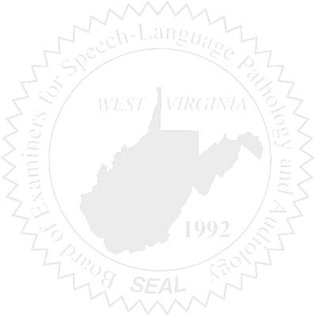

1. Call to Order

New Business

1. Proposed Rules