West Virginia Board of Examiners for

Speech-Language Pathology and Audiology

Board Members

Vickie Pullins, M.A., CCC-SLP, President

Amber Settles, M.Ed. CCC-SLP, Secretary

Dr. Michael J. Zagarella, Au.D., CCC-A

R. Michael Squires, Au.D., F-AAA

Heather Waselchalk, M.S. CCC-SLP

Amanda Bonner, Hearing Aid Specialist

Ruth Rowan, Citizen Member

October 23, 2024 at 5:30PM

BOARD MEETING AGENDA

VIA ZOOM CONFERENCE

OGLEBAY RESORT

465 LODGE DRIVE

WHEELING, WV 26003

1. 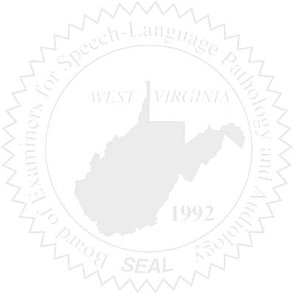Call to order
2. Approve minutes for October 1, 2024

Old Business

1. Proposed Rules