West Virginia Board of Examiners for Speech-Language Pathology and Audiology

May 30, 2024
Time: 5:30 PM Board Meeting
Location: Video Conference Meeting Board Office
99 Edmiston Way – Suite 214
Buckhannon, WV 26201

Present: Board President, Vickie Pullins
Board Secretary, Amber Settles
Board Member, Heather Waselchalk
Board Member, Dr. Michael Zagarella
Board Member, Amanda Bonner
Board Member. Dr. Michael Squires
Board Member, Ruth Rowan
Board Attorney: Joanne Vella

Executive Director, Pamela Coughlin

The May 30, 2024, meeting of the West Virginia Board of Speech-Language Pathology and Audiology was called to order at the Board office at 99 Edmiston Way, Buckhannon, West Virginia, via Zoom at 5:30 PM by Board Secretary, Amber Settles. Agenda and Zoom invitation were put on the Boards website for the public to attend via telephone.

Ruth Rowan made a motion to approve May 30, 2024 minutes. Dr. Michael Squires seconded the motion. Motion carried.

Dr. Squires made motion to approve March 2024 Pcard. Heather Waselchalk seconded the motion. Motion carried.

The board held an open discussion on a hearing aid dealer trainee that did not pass the ILE or get the score they needed to renew their permit. After discussion, the trainee cannot renew expired permit but can reapply for a new trainee permit.

Dr. Zagarella made motion to accept rules proposed. Amber Settles seconded the motion. Motion carried.

Dr. Squires made a motion to go into Executive session at 6:14PM. Amber Settle seconded the motion. Motion carried.

Dr. Squires recused himself from Executive Session for complaint #59. Amanda Bonner recused herself for hearing aid dealer complaint #3 and #4.

Dr. Zagarella made motion to come out of Executive Session. Ruth Rowan seconded the motion. Motion carried.

Dr. Zagarella made a motion to ask #58 licensee for supportive documentation for each item in the complaint. Amber Settles seconded the motion. Motion carried.

Amber Settles mad a motion to contact licensee to see if he received the certified letter. Dr. Zagarella seconded the motion. Motion carried.

Dr. Zagarella made a motion to request supervision documentation from licensee and supervisor. Heather Waselchalk seconded the motion. Motion carried.

D. Squires made a motion to dismiss # 4 complaint. Ruth Rowan seconded the motion. Motion carried.

Amber Settles made a motion to adjourn. Heather Waselchalk seconded the motion. Meeting adjourned at 7:06PM.

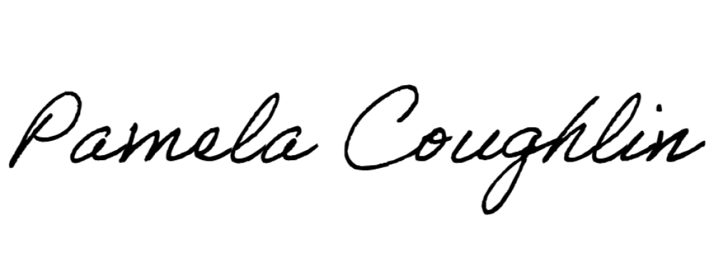
Respectfully submitted,

Pamela Coughlin, Executive Director
for
Amber Settles, Board Secretary

