West Virginia Board of Examiners for Speech-Language Pathology and Audiology

August 6, 2024
Time: 5:30 PM Board Meeting
Location: Video Conference Meeting Board Office
99 Edmiston Way – Suite 214
Buckhannon, WV 26201

Present: Board President, Vickie Pullins
Board Secretary, Amber Settles
Board Member, Heather Waselchalk
Board Member, Dr. Michael Zagarella
Board Member, Amanda Bonner
Board Member. Dr. Michael Squires
Board Member, Ruth Rowan

Executive Director, Pamela Coughlin

The August 6, 2024, meeting of the West Virginia Board of Speech-Language Pathology and Audiology was called to order at the Board office at 99 Edmiston Way, Buckhannon, West Virginia, via Zoom at 5:30 PM by Board President Vickie Pullins. Agenda and Zoom invitation were put on the Boards website for the public to attend via telephone.

Amanda Bonner made a motion to go into Executive Session. Ruth Rowan seconded the motion. Motion carried.

Dr. Michael Squires made motion to come out of Executive Session. Amber Settles seconded the motion. Motion carried.

Vickie Pullins recommended we gather more information on complaint #59 and #61 and then make a decision. Ms. Pullins is going to reach out to other State Boards to see how they handle patient abandonment and Pam Coughlin will reach out to the Ethics Commission.

Dr. Michael Squires and Amanda Bonner will work on a handbook to assist in proctoring the practical exam. Dr. Squires recommended we come up with an expectation sheet for the candidates so they will know what to expect the day of the practical exam.

Dr. Squires reviewed his experience proctoring 2 practical exams with the Board. Dr. Squires recommended we look at the scoring on the practical exam and put a safeguard in place for proctoring the exam. Amanda Bonner recommended we inform the candidates that are taking the practical exam, that the board will review and make the final decision if they pass or fail the exam. The Board agreed that would protect the Audiologist and Hearing Aid Specialist proctoring the exam. Dr. Squires and Ms. Bonner will work together on updating the practical exam scoring sheet.

Amanda Bonner made motion to adjourn. Dr. Michael Zagarella seconded motion. Motion carried.

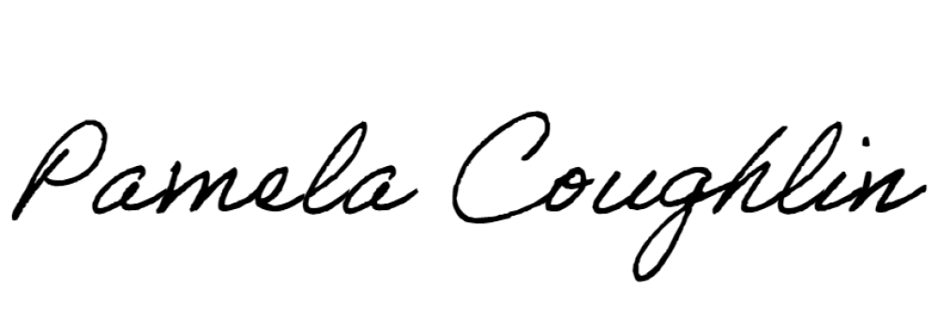
Respectfully submitted,

Pamela Coughlin, Executive Director
for
Amber Settles, Board Secretary

