West Virginia Board of Examiners for Speech-Language Pathology and Audiology

January 21, 2025
Time: 5:30 PM Board Meeting
Location: Video Conference Meeting Board Office
99 Edmiston Way – Suite 214
Buckhannon, WV 26201

Present: Board President, Vickie Pullins
Board Secretary, Amber Settles
Board Member, Dr. Michael Zagarella
Board Member. Dr. Michael Squires
Board Member, Heather Waselchalk
Board Member, Amanda Bonner
Board Member, Ruth Rowan
Board Attorney, Joanne Vella

Executive Director, Pamela Coughlin

The January 21, 2025, meeting of the West Virginia Board of Speech-Language Pathology and Audiology was called to order at the Board office at 99 Edmiston Way, Buckhannon, West Virginia, via Zoom at 5:30 PM by Board President Vickie Pullins. Agenda and Zoom invitation were put on the Boards website for the public to attend via telephone.

Ruth Rowan made a motion to approve board meeting minutes for October 1, 2024. Amber Settles seconded the motion. Motion carried.

Dr. Michael Squires made a motion to approve Pcard for September, October, November 2024 and financials for December 2024. Ruth Rowan seconded the motion. Motion carried.

Vickie Pullins updated the Board on the Bill for the background check that Carl Fletcher created for us and that Senator Eric Tarr will sponsor our Bill. Ms. Pullins reached out to legal counsel Jeff Johnson and he added the Hearing Aid Dealers to the Bill. Once the Health Committee has a chairperson, Ms. Pullins will reach out to them.

Ms. Pullins informed the Board that the Interstate Compact will go live May of 2025. She said the Compact background checks will be with be for new licensees.

Pam Coughlin asked the Board to approve the lodging and travel for Vickie Pullins, she will be attending the Board of Director’s meeting for National Council for State Boards of Examiners in South Carolina. D. Michael Squires made motion to approve travel and lodging. Amanda Bonner seconded the motion. Motion carried.

Vickie Pullins informed the Board that National Council for State Boards of Examiners will he held in Mount Pleasant, South Carolina on September 19th and 20th, 2025.

Heather Wasselchalk made a motion to go into Executive Session. Ruth Seconded the Motion. Motion carried.

D. Michael Squires recused himself for the review if complaint #59 & #61.

Amber Settles motioned to come out of Executive Session. Ruth Rowan seconded the motion. Motion carried.

Dr. Michael Squires joined the meeting.

Heather Wasselchalk made a motion to dismiss complaint #58 for no probable cause. Amber Settles seconded the motion. Motion was carried.

While in Executive Session, our Board Council, Joann Vella and consensus of the Board, we will advancing toward to hearing for complaint #59 & #61.

Dr. Michael Squires made motion to adjourn. Amanda Bonner seconded motion. Motion carried.

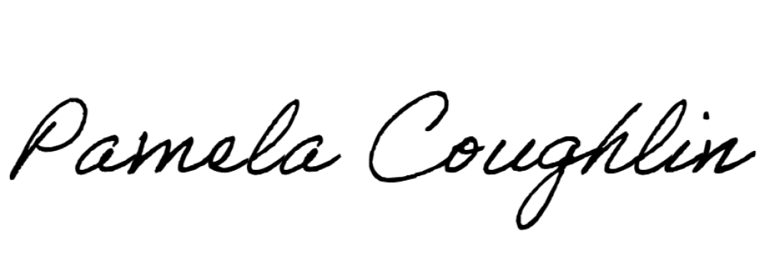
Respectfully submitted,

Pamela Coughlin, Executive Director
for
Amber Settles, Board Secretary

