West Virginia Board of Examiners for Speech-Language Pathology and Audiology

October 23, 2024
Time: 5:30 PM Board Meeting
Location: Video Conference Meeting Board Office
99 Edmiston Way – Suite 214
Buckhannon, WV 26201

Present: Board President, Vickie Pullins
Board Member, Heather Waselchalk
Board Member, Dr. Michael Zagarella
Board Member, Amanda Bonner
Board Member. Dr. Michael Squires
Board Member, Ruth Rowan
Board Attorney, Joanne Vella

Executive Director, Pamela Coughlin

The October 23, 2024, meeting of the West Virginia Board of Speech-Language Pathology and Audiology was called to order at the Oglebay at 465 Lodge Drive, Wheeling, West Virginia, via Zoom at 5:30 PM by Board President Vickie Pullins. Agenda and Zoom invitation were put on the Boards website for the public to attend via telephone.

Ruth Rowan made a motion to approve board meeting minutes for October 1, 2024. Amanda Bonner seconded the motion. Motion carried.

Dr. Michael Squires made motion to withdraw proposed rules Rule 1,3,4,5 and keep rule 2. Heather Waselchalk seconded the motion. Motion carried.

Dr. Michael Squires made motion to adjourn. Amanda Bonner seconded motion. Motion carried.

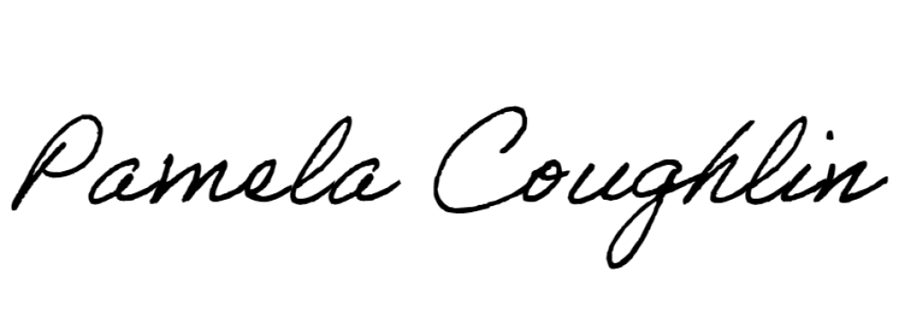
Respectfully submitted,

Pamela Coughlin, Executive Director
for
Amber Settles, Board Secretary

