West Virginia Board of Examiners for Speech-Language Pathology and Audiology

July 10, 2024
Time: 5:30 PM Board Meeting
Location: Video Conference Meeting Board Office
99 Edmiston Way – Suite 214
Buckhannon, WV 26201

Present: Board President, Vickie Pullins
Board Secretary, Amber Settles
Board Member, Heather Waselchalk
Board Member, Dr. Michael Zagarella
Board Member, Amanda Bonner
Board Member. Dr. Michael Squires
Board Member, Ruth Rowan
Board Attorney: Joanne Vella

Executive Director, Pamela Coughlin

The July 10, 2024, meeting of the West Virginia Board of Speech-Language Pathology and Audiology was called to order at the Board office at 99 Edmiston Way, Buckhannon, West Virginia, via Zoom at 5:31 PM by Board Secretary, Amber Settles. Agenda and Zoom invitation were put on the Boards website for the public to attend via telephone.

Amanda Bonner made a motion to approve May 16, 2024 and May 30, 2024 minutes. Ruth Rowan seconded the motion. Motion carried.

Amber Settles made motion to approve March 2024 Pcard. Amanda Bonner seconded the motion. Motion carried.

Pam Coughlin reviewed a provisional application with the Board. The licensee renewed his license but was unable to complete his CF hours due to the passing of his father and health issues. Vickie Pullins recommended I reach out to the licensee to get more information about the health issues. Amber Settles stated we need to set a time frame for the licensee to complete his CF hours and to make sure he can complete the hours in one year.

Vickie Pullins discussed getting a part time employee to assist through renewal. The members recommended Pam Coughlin to reach out to Linda Lyter, Wesleyan College, West Virginia University and Marshall University for individuals. The starting pay will be $20 an hour.

Vickie Pullins informed the members National Council of State Board conference will be help September 26, 2024 to September 28, 2024 in San Antonio, Texas. Ms. Pullins recommended the board be a sponsor for the conference. Dr. Michael Zagarella made motion to sponsor the NCSB conference in the amount of $1500. Amber Settles seconded the motion. Motion carried.

Vickie Pullins discussed the transcript for a Speech Pathologist Assistant. Ms. Pullins recommended Pam Coughlin to reach out the individual and have her contact Heather Waselchalk with the Board of Education.

The Board had an open discussion on the public comments we received on the proposed rules. Vickie Pullins and Pam Coughlin will summarize the public comments and submit the summary with the rules.

Dr. Michael Squires made motion to go into Executive Session. Amber Settles seconded the motion. Motion carried.

Dr. Squires recused himself for complaint #59 and #61.

Amanada Bonner recued herself for complaint #3.

Dr. Squires rejoined Executive Session for complaint #3.

Dr. Zagarella made motion to come out of Executive Session. Amber Settles seconded the motion. Motion carried.

Vickie Pullins recommended we ask for more documentation for complaint #58 and #59. Ms. Pullins stated we need to reach out to the hearing aid manufacture for #61 complaint and reach out to the licensee and ask why it took so long to for the customer to get their hearing aids.

Heather Waselchalk made motion to dismiss Hearing Aid Dealer #3 complaint due to our rules cannot support documentation of supervision.. Ruth Rowan seconded the motion. Motion carried.

Amber Settles made motion to adjourn. Ruth Rowan seconded motion. Motion carried.

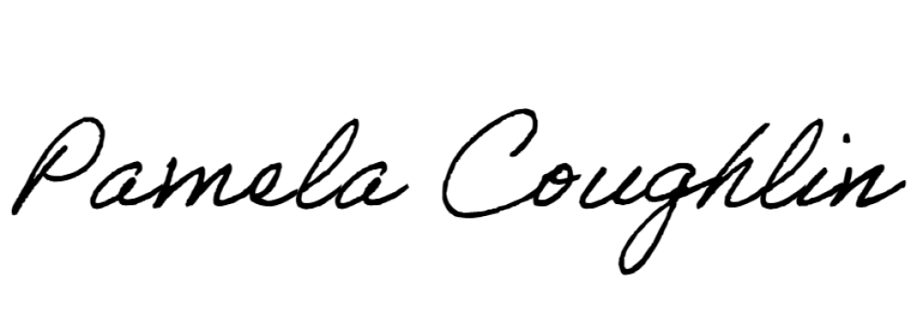
Respectfully submitted,

Pamela Coughlin, Executive Director
for
Amber Settles, Board Secretary

