West Virginia Board of Examiners for
Speech-Language Pathology and Audiology

Board Members
Vickie Pullins, M.A., CCC-SLP, President
Amber Settles, M.Ed. CCC-SLP, Secretary

Dr. Michael J. Zagarella, Au.D., CCC-A

R. Michael Squires, Au.D., F-AAA
Heather Waselchalk, M.A. CCC-SLP
Amanda Bonner, Hearing Aid Specialist
Ruth Rowan, Citizen Member

April 22, 2024

BOARD MEETING AGENDA
Board Office via Video Conference
99 Edmiston Way
Suite 214
Buckhannon, WV 26201

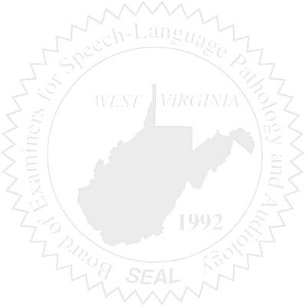
- Call to Order
- Approve Minutes for April 9, 2024

New Business

- Budget for FY 2025
- Licensee in their CFY doing PRN work

Complaints

- Complaint # 60
- HAD Complaint #4- Amanda Bonner to recuse herself

