West Virginia Board of Examiners for Speech-Language Pathology and Audiology

May 16, 2024
Time: 5:30 PM Board Meeting
Location: Video Conference Meeting Board Office
99 Edmiston Way – Suite 214
Buckhannon, WV 26201

Present: Board President, Vickie Pullins
Board Secretary, Amber Settles
Board Member, Heather Waselchalk
Board Member, Dr. Michael Zagarella
Board Member, Amanda Bonner
Board Member. Dr. Michael Squires
Board Member, Ruth Rowan

Executive Director, Pamela Coughlin

The May 16, 2024, meeting of the West Virginia Board of Speech-Language Pathology and Audiology was called to order at the Board office at 99 Edmiston Way, Buckhannon, West Virginia, via Zoom at 5:30 PM by Board President Vickie Pullins. Agenda and Zoom invitation were put on the Boards website for the public to attend via telephone.

The board reviewed the proposed rules and made that final changes. Pam Coughlin will send proposed rules to Mauren Lewis to make sure the formatting is correct.

Next board meeting will be held May 30, 2024 at 5:30PM to review complaints responses.

There was a brief discussion of Over the Counter Hearing Aids.

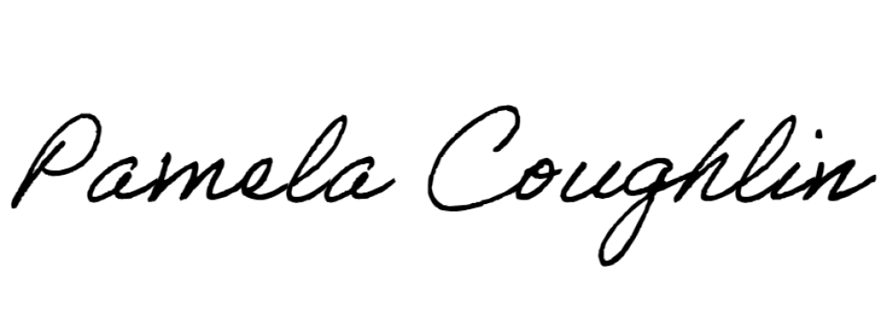
Respectfully submitted,

Pamela Coughlin, Executive Director
for
Amber Settles, Board Secretary

