West Virginia Board of Examiners for Speech-Language Pathology and Audiology

February 13, 2024 Board meeting
Time: 5:00 PM
Location: Video Conference Meeting Board Office
99 Edmiston Way – Suite 214
Buckhannon, WV 26201

Present: Board President, Vickie Pullins
Board Secretary, Amber Settles
Board Member, Michael Zagarella
Board Member, Heather Waselchalk
Board Member, R. Michael Squires
Board Member, Amanda Bonner
Board Member, Ruth Rowan
Board Attorney, Joanne Vella

Executive Director, Pamela Coughlin

The February 13, 2024, meeting of the West Virginia Board of Speech-Language Pathology and Audiology was called to order in the Board office at 99 Edmiston Way, Buckhannon, West Virginia, via Zoom at 5:01 PM by Board President Vickie Pullins. Agenda and Zoom invitation were put on the Boards website for the public to attend via telephone.

Introductions

Vickie Pullins introduced and welcomed our new Citizen Board member The Honorable Ruth Rowan.

Approve Minutes

Dr. Michael Zagarella motioned to approve the minutes for January 11, 2024. Amber Settles seconded the motion. Motion carried.

Practical Examination

Amanda Bonner informed the board that she will be giving the Practical Exam on February 23, 2024 in her office. Dr. Michael Squires recommended the board purchase equipment for the Hearing Aid Dealer practical exam.

Review Complaints

Amanda Bonner made a motion to go into executive session to discuss 2 complaints, Dr. Michael Squires seconded the motion. Motion carried.

Dr. Michael Squires recused himself before the review of Complaint #2.

Ruth Rowan motioned to come out of Executive Session. Dr. Michael Zagarella seconded the motion. Motion carried.

Pam Coughlin informed the board members that the Hearing Aid Dealer Company for complaint #1 is not licensed in West Virginia and it was dismissed. Pam Coughlin will send a certified letter to complainant and the Hearing Aid Company.

Vickie Pullins and Joanne Vella recommended the board office to reach out to the complainant #2 and get their response to the complaint. Pam Coughlin will also ask for proof of the certification to use “Audioprosthologist”.

Vickie Pullins discussed having a board meeting in person in April at the board office in Buckhannon.
Ms. Pullins reminded the member to send their biography and picture to Pam Coughlin so she can put the information on the board’s website.

Amanda Bonner made a motion to adjourn. Amber Settles seconded the motion. Motion carried. Meeting adjourned at 5:45 PM.

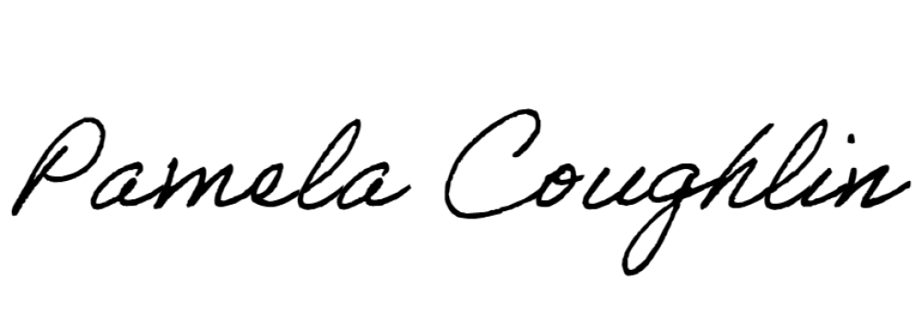
Respectfully submitted,

Pamela Coughlin, Executive Director for
Amber Settles, Board Secretary

