West Virginia Board of Examiners for
Speech-Language Pathology and Audiology

Board Members
Erin Leigh-Ann Browning, M.A., CCC-SLP, President
Vickie Pullins, M.A., CCC-SLP, Secretary

Dr. Michael J. Zagarella, Au.D., CCC-A
Dr. Vernon N. Mullins, Au.D, CCC-A
Joe E. Richards, M.A., Citizen Member

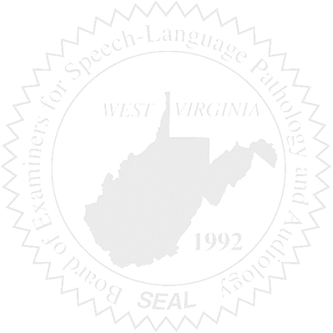
BOARD MEETING
March 31, 2017
Friday @ 5:00 PM
WVSHA Conference
300 Conference Center Way
Bridgeport, WV 26330
Also available via Video Conference

- Call to Order

- Approval of Minutes – February 22, 2017

- PCard Purchasing Report

- Complaints – Updates (Patty Nesbitt for Greg Foster
- Complaint #46 – Dismissal Letter
- Complaint #44 Supervisor of unlicensed Clinical Fellow – Hearing Update
- Elissa Lindsay Appeal Update, if any – Writ of Mandamus

5. Old Business
- License Renewal Stats

6. New Business
- WVSHA Vendor Table

