West Virginia Board of Examiners for
Speech-Language Pathology and Audiology

Board Members

Dr. Michael J. Zagarella, Au.D., CCC-A, President
Vickie Pullins, M.A., CCC-SLP, Secretary
Dr. Vernon N. Mullins, Au.D, CCC-A
Erin Leigh-Ann Browning, M.A., CCC-SLP
Joe E. Richards, M.A., Citizen Member

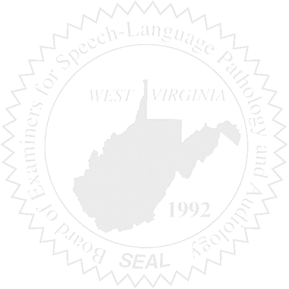
BOARD MEETING
February 17, 2016
6:30 PM
Board Office via Video Conference Call
99 Edmiston Way
Suite 214
Buckhannon, WV 26201

- Call to Order

- Approval of Minutes – January 6, 2016

- Financial Report including Purchasing Card expenditures, etc.

- Complaints
- Ronnie Warrington Legal Issue update
- #44 Supervisor of unlicensed CF
- Elissa Lindsay Appeal

5. Old Business
- Update on Legislature & Chapter 30 Boards, i.e., Febr. 9 meeting w/Delegate Howell
- Licensure Stats Update
- PPE Supervision Requirements/Clarification – Rules Change?

6. New Business
- FARB Conference – Vickie Pullins
- WVSHA Conference, April – Vendor Table?
- March Meeting Date

