West Virginia Board of Examiners for
Speech-Language Pathology and Audiology

Board Members
Erin Leigh-Ann Browning, M.A., CCC-SLP, President
Vickie Pullins, M.A., CCC-SLP, Secretary

Dr. Michael J. Zagarella, Au.D., CCC-A
Dr. Vernon N. Mullins, Au.D, CCC-A
Joe E. Richards, M.A., Citizen Member

BOARD MEETING AGENDA
January 8, 2019 @ 5:00 PM
Board Office via Video Conference
99 Edmiston Way
Suite 214
Buckhannon, WV 26201

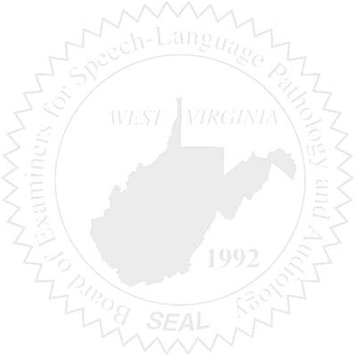
- Call to Order

COMPLAINTS

- Closed Case #47 – Request from Licensee - Patty
- Case #52 – Request for reducing suspension

NEW BUSINESS

- FARB – Conference January 25 – 27, 2019
New Orleans, LA

