West Virginia Board of Examiners for Speech-Language Pathology and Audiology

July 24, 2023 Board Meeting
Time: 5:00 PM
Location: Video Conference Meeting Board Office
99 Edmiston Way – Suite 214
Buckhannon, WV 26201

Present: Board President, Vernon Mullins Board Secretary, Vickie Pullins Board Member, Michael Zagarella Board Member, Heather Waselchalk Board Member, Amber Settles
Citizen Member, Joe E. Richards
Executive Director, Pamela Coughlin

The meeting was called to order at 5:00 PM by Vernon Mullins, Board President.
Vern Mullins stated the meeting is to vote on the proposed rules. Joe Richards explained if the changes are substantial, the rules will have to go for public comment again.

Joe Richards and Vickie Pullins stated that the Governor’s office said the new members can vote.

Vickie Pullins mentioned the restrictions in the proposed rules would cause some problems and that we needed more input from the Hearing Aid Dealers.

Vickie Pullins recommended we leave the Hearing Aid Dealer Rules as is and work on them throughout this coming year.

Michael Zagarella motioned we use the Hearing Aid Dealers law to give us time to work on their rules. Vickie Pullins seconded the motion. All the board members voted to yes to use Hearing Aid Dealer rules and not file the proposed rules. Motion carried.

Joe Richards made a motion to adjourn. Amanda Bonner seconded the motion. The meeting adjourned at 5:36 PM.

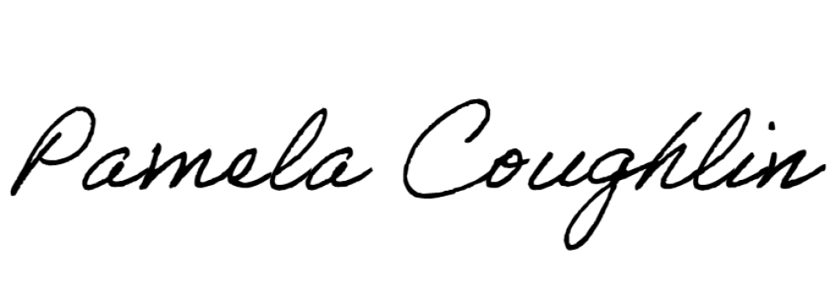
Respectfully submitted,

Pamela Coughlin, Executive Director for
Vickie Pullins, Board Secretary

